Falling Housing Prices and Underwater Mortgages - Full Answer

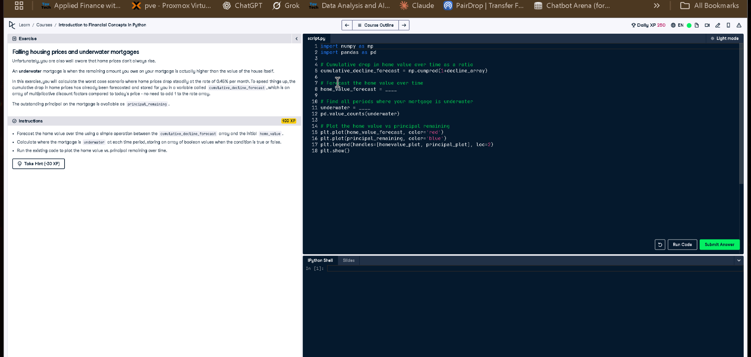

# Full Code Answer:

import numpy as np  
import pandas as pd  
  
# Cumulative drop in home value over time as a ratio  
cumulative_decline_forecast = np.cumprod(1 + decline_array)  
  
# Forecast the home value over time  
home_value_forecast = home_value * cumulative_decline_forecast  
  
# Find all periods where your mortgage is underwater  
underwater = principal_remaining > home_value_forecast  
pd.value_counts(underwater)  
  
# Plot the home value vs principal remaining  
plt.plot(home_value_forecast, color='red')  
plt.plot(principal_remaining, color='blue')  
plt.legend(handles=[homevalue_plot, principal_plot], loc=2)  
plt.show()

# Question:

How do we calculate home value decline over time and determine when a mortgage becomes underwater?

# 20-word Explanation (Question):

An underwater mortgage occurs when the remaining principal surpasses current home value due to declining property market trends.

# Answer:

We use np.cumprod() to calculate declining home values, then check if principal_remaining exceeds home_value_forecast for underwater status.

# 20-word Explanation (Answer):

By multiplying home value with cumulative decline factors, we compare it with principal_remaining to find underwater mortgage periods.